Fraud Detection on Bank Payments

Problem Definition and Scope

Identification of Business Problem
The project focuses on fraud detection in bank payments, aiming to develop models that can accurately identify fraudulent transactions to prevent financial losses.

Scope and Boundaries of the Project
The scope includes collecting and preprocessing transaction data, selecting appropriate algorithms, training and evaluating models, and deploying the best-performing model for fraud detection.

Data Sources and Availability
Transaction data from a bank's payment system (Kaggle) is used for this project. The dataset contains features such as transaction amount, type, step, and target variable indicating fraudulent or non-fraudulent transactions.

Success Criteria
The success of the project will be evaluated based on the model's performance metrics, including accuracy, precision, recall, F1-score, and area under the ROC curve.

Data Collection and Preparation

Gathering Data
Transaction data is collected from the bank's payment system and stored in a structured format for further analysis.

Dataset Information:
Dataset Link: https://www.kaggle.com/code/shankeshrajums/fraudulent-transaction-model
Number of Entries: 6,362,620 rows
Number of Columns: 11 columns

Data Types and Formats
The data consists of numerical and categorical variables, including transaction amount, type of transaction.

Exploring and Understanding the Data
Exploratory data analysis is conducted to gain insights into the distribution of features, identify patterns, and detect any anomalies or missing values.
Dataset has the following Variables:

- step: A temporal feature indicating the transaction step in the sequence of transactions.
- type: The type of transaction (e.g., cash_out, payment, transfer, etc.), which helps identify potential patterns in fraudulent behavior.
- amount: The monetary value of the transaction, which is a crucial factor in fraud detection.
- nameOrig: Identifier for the origin account associated with the transaction.
- oldbalanceOrg: The balance of the origin account before the transaction.
- newbalanceOrig: The balance of the origin account after the transaction.
- nameDest: Identifier for the destination account involved in the transaction.
- oldbalanceDest: The balance of the destination account before the transaction.
- newbalanceDest: The balance of the destination account after the transaction.
- isFraud: The target variable indicating whether the transaction is fraudulent (1) or not (0).
- isFlaggedFraud: A binary variable that indicates whether a transaction has been flagged for potential fraud (1) or not (0). This feature can assist in identifying known fraudulent activities and helps in training the model to recognize similar patterns.
Table 1: Detailed Information of the Dataset

Description | Value
How many observations are there in the  dataset? | 6,362,620
How many binary/categorical variables? | 2 (isFraud, type)
How many continuous variables? | 9
What is the target variable? | isFraud
What is the percentage of each class of the  target variable? | Fraud: 0.17% (approx.) / Not Fraud: 99.83%  (approx.)
What is the mean value of the target  variable? | Since our target variable is binary, we cannot  provide a mean value.

Data Preprocessing

Data Cleaning
Data cleaning involves handling missing values, removing duplicates, and addressing any inconsistencies in the dataset.

Handling Missing Values
Missing values are imputed or removed using appropriate techniques to ensure data quality. There are no missing values in the data set.

Feature Selection and Engineering
Relevant features are selected or engineered to improve model performance and reduce dimensionality.

Data Transformation and Scaling
Data transformation techniques such as normalization or standardization are applied to scale features and improve model convergence.

Data Visualization and Prediction Techniques

Data Visualization:
- Explore distributions of key variables: Use histograms and box plots to visualize the distribution of transaction amounts, account balances, and other continuous variables.
- Examine correlations between variables: Utilize a correlation matrix heatmap to identify relationships between numerical features, including transaction amounts and account balances.
- Visualize the distribution of fraudulent transactions: Use count plots to show the distribution of the target variable (isFraud) across categorical features like transaction type and account origin.

Prediction Techniques:
- Utilize classification algorithms: Implement various classification algorithms such as Linear Regression, Logistic Regression, and Naive Bayes to predict fraudulent transactions.
- Implement cross-validation: Use k-fold cross-validation to evaluate model performance and ensure that the model generalizes well to unseen data.

Data Preprocessing

Handling the data:
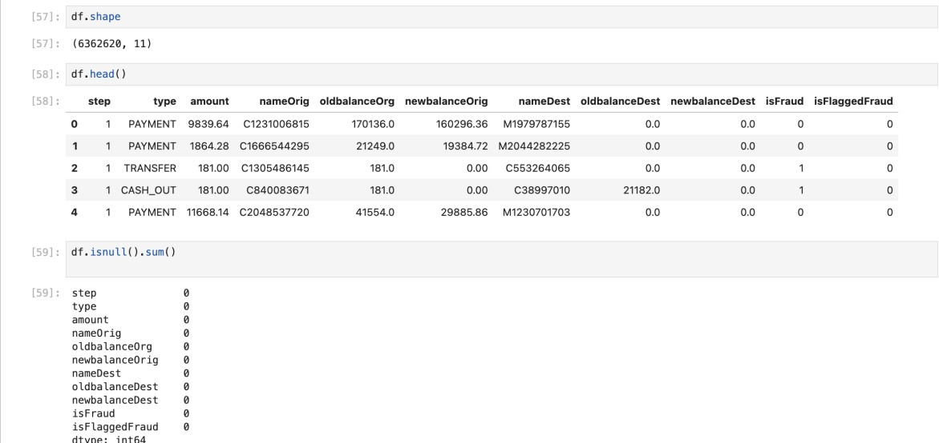
In the below image you can see the shape of the dataset and 5 rows of the dataset and checking if there are any missing values present in the dataset.

Data Visualization:

Correlation Matrix:
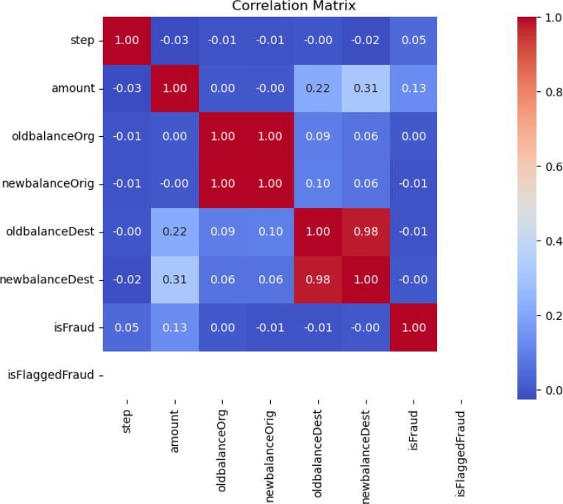

Key Findings:
- High Correlation Between oldbalanceOrg and newbalanceOrig:
The correlation between `oldbalanceOrg` (the origin account's balance before the transaction) and
`newbalanceOrig` (the origin account's balance after the transaction) is 1.00, indicating a perfect linear relationship. This is expected since the new balance is typically a direct result of subtracting the transaction amount from the old balance.
- High Correlation Between oldbalanceDest and newbalanceDest:
Similarly, there’s a 0.98 correlation between `oldbalanceDest` (the destination account’s balance before the transaction) and `newbalanceDest` (the destination account’s balance after the transaction), meaning these features are highly dependent. Again, this makes sense as the destination account's new balance is based on adding the transaction amount to the old balance.
- Moderate Correlation of amount with newbalanceDest:
The transaction `amount` has a moderate correlation of 0.31 with `newbalanceDest`. This suggests that larger transaction amounts tend to result in a higher balance for the destination account after the transaction, as expected.
- Low Correlation of Features with isFraud:
None of the features (like `amount`, `oldbalanceOrg`, `newbalanceOrig`, etc.) show a strong correlation with `isFraud`. The highest is `amount` with a 0.13 correlation, which suggests that the transaction amount has a minor relationship with fraudulent activity, but it's not strong enough to solely predict fraud.
This indicates that fraud detection might require more complex relationships beyond simple linear correlations, possibly involving combinations of features or non-linear patterns.
- No Significant Correlation with isFlaggedFraud:
The feature `isFlaggedFraud` was not correlated with any other features. This could imply that the system’s flags for fraud do not align well with the transaction patterns shown by these variables.

Key Takeaways:
    - The amount feature shows some minor correlation with fraud, but no feature shows a very strong relationship with the `isFraud` label.
    - The strong correlations between balance-related features (like `oldbalanceOrg` and
`newbalanceOrig`) suggest redundancy, meaning some of these features could be reduced or engineered further to remove multicollinearity.
    - More sophisticated models (e.g., non-linear models like Random Forest, XGBoost, or Neural Networks) may be necessary to capture complex patterns for predicting fraud.

6.1 ScatterPlot:
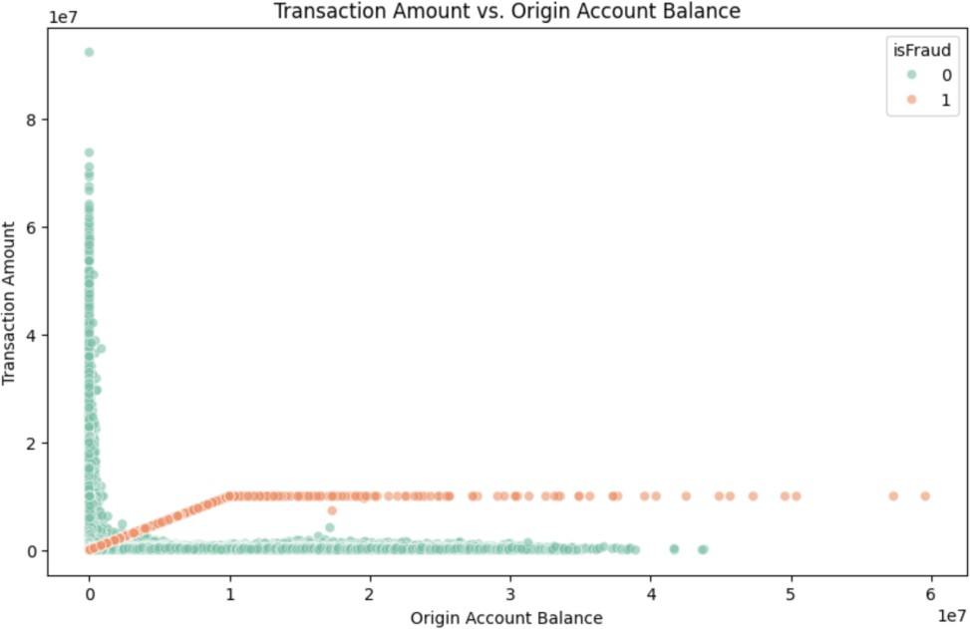

6.2.1 Key Findings:
- Fraudulent Transactions (Orange Dots):
Fraudulent transactions (denoted by the orange dots) tend to occur when the transaction amount is very close to the origin account balance. This pattern is visible as a near-linear line where the transaction amount equals the origin account balance.
These transactions cluster in the higher transaction amount range, specifically above 0.5 x 10⁷ (5 million), suggesting that fraud is more prevalent with larger transaction amounts.
- Non-Fraudulent Transactions (Green Dots):
Non-fraudulent transactions (green dots) are scattered across a wider range of origin account balances and transaction amounts.
Most non-fraudulent transactions involve lower amounts, concentrated below 0.2 x 10⁷ (2 million) for the transaction amount, and are spread across various origin account balances.

Fraud Tends to Follow Large Withdrawals:
The fraud transactions are highly concentrated where the transaction amount is a significant portion of the origin balance, implying that fraud often involves nearly depleting the balance of an account.

Sparse Fraudulent Activity in Lower Amounts:
Fraudulent activity is very rare for smaller transaction amounts (below 0.5 x 10⁷), while the vast majority of transactions in this range are non-fraudulent.

Key Takeaways:
    - Transaction size and origin account balance are critical indicators of fraud. High-value transactions that closely match the origin account balance are strong predictors of fraudulent behavior.
    - Non-fraudulent transactions are more evenly distributed across different origin balances and transaction amounts, while fraudulent transactions are clustered in specific, larger transaction categories.
    - This plot reinforces the idea that features related to balance amounts and transaction sizes should play a significant role in the modeling process for fraud detection.

Dimensionality Reduction using Under Sampling:
Dimensionality reduction is an essential step in preparing datasets for machine learning, especially in caseswhere there is a significant class imbalance. For this project, the dataset exhibited an extreme imbalance between the majority class (isFraud = 0) and the minority class (isFraud = 1). The overwhelming prevalence of non-fraudulent transactions posed a challenge for the model to effectively learn patterns associated with fraudulent activities.

Purpose of Dimensionality Reduction
In this context, dimensionality reduction aimed to address two primary challenges:
Balancing the Class Distribution: Ensuring that the dataset is not biased towards the majority class, which could result in the model overlooking critical patterns in the minority class.
Improving Model Performance: By balancing the dataset, the model could focus on learning representative features for fraudulent transactions, ultimately enhancing detection accuracy.

Implementation of Undersampling
To achieve dimensionality reduction, an undersampling technique was employed. This involved reducing the number of data points in the majority class (isFraud = 0) to match the number of data points in the minority class (isFraud = 1). The process was as follows:
Randomly select a subset of samples from the majority class.
Combine the sampled majority class with the minority class to create a balanced dataset.
Ensure that the balanced dataset retains its statistical significance by validating results on the test dataset.

Results of Undersampling:
Before applying under sampling:
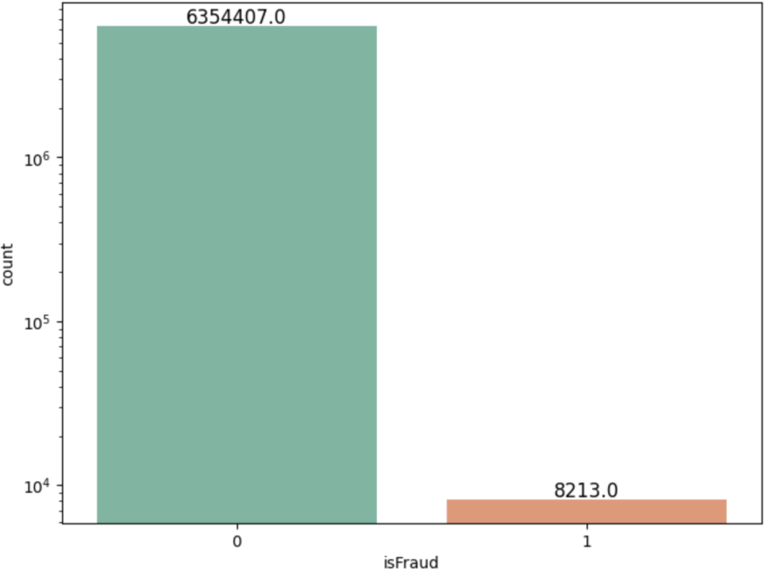
After applying under sampling:
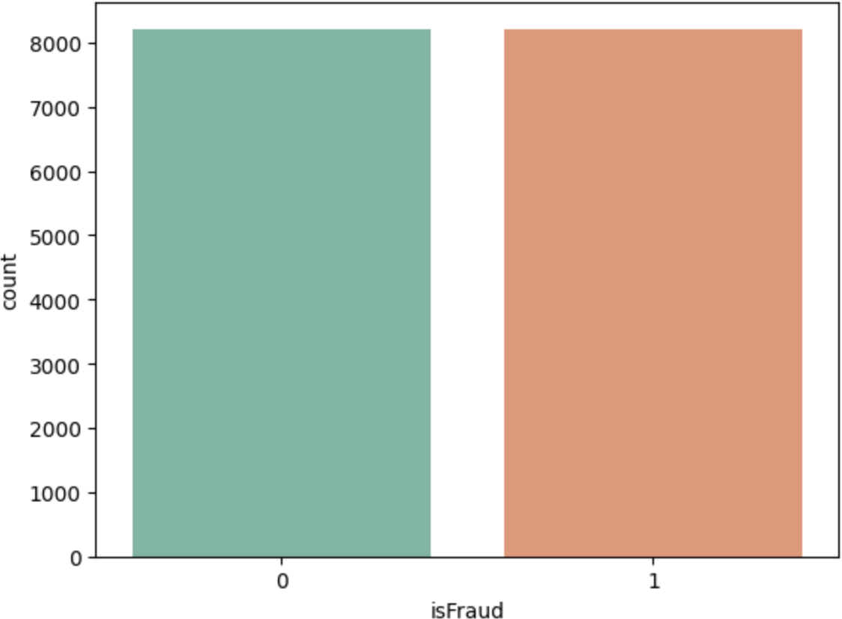

The distribution of classes was balanced, as shown in Figure. The minority class (isFraud = 1) represented approximately 50% of the total data points, ensuring equal representation in the model training process.
This reduction allowed the model to allocate equal importance to both classes, thereby improving

the recall of fraudulent transactions.
Undersampling proved to be an effective strategy for addressing the class imbalance in the dataset. By reducing the majority class samples, dimensionality reduction ensured that the machine learning models focused equally on both classes, improving their ability to detect fraud. However, the limitations of undersampling highlight the importance of complementing this technique with robust validation methods to maintain model accuracy.

Data Prediction Techniques:

Random Forest:
Random Forest is an ensemble learning technique that builds multiple decision trees during training and outputs the mode (classification) or mean (regression) of the predictions from individual trees.

Mechanism:
Random Forest introduces randomness into the tree-building process by selecting a random subset of features for splitting at each node and by bootstrapping samples (random sampling with replacement). This approach ensures diversity among the trees, leading to better generalization.

Strengths:
Handles large datasets with higher dimensionality effectively. Resistant to overfitting due to ensemble averaging.
Provides feature importance, which helps in understanding the dataset.

Limitations:
Computationally expensive for large datasets.
Harder to interpret compared to individual decision trees.

Relevance to Fraud Detection:
Random Forest is highly effective for fraud detection because it can handle imbalanced datasets and complex interactions between features, which are typical in fraudulent transactions.

Results:
Confusion matrix :
[[2319 160]
[ 53 2396]]
Outcome values :
2319 160 53 2396
Classification report :
precision recall f1-score support

1 0.98 | 0.94 | 0.96 | 2479
0 0.94 | 0.98 | 0.96 | 2449
accuracy |  | 0.96 | 4928
macro avg | 0.96 | 0.96 0.96 4928
weighted avg | 0.96 | 0.96 0.96 4928

Accuracy : 95.7 % Precision : 97.8 % Recall : 93.5 % F1 Score : 0.956
Specificity or True Negative Rate : 97.8 % Balanced Accuracy : 95.6 %
MCC : 0.914
roc_auc_score: 0.957
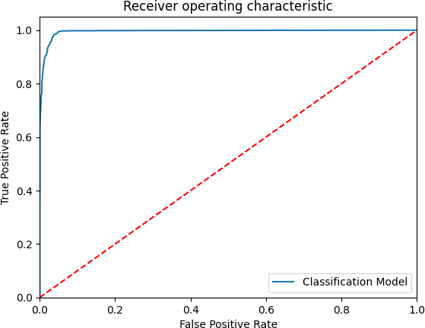

Decision Trees:
Decision Trees are hierarchical models that split the data into branches based on specific feature thresholds to reach a decision.

Mechanism:
At each node, the algorithm selects a feature and threshold that maximizes information gain (or minimizes Gini impurity) to create splits. The tree grows until certain stopping criteria are met, such as maximum depth or minimum samples per leaf.

Strengths:
Easy to understand and interpret.
Requires minimal data preprocessing (no scaling required). Captures non-linear relationships effectively.

Limitations:
Prone to overfitting, especially with deep trees.
Sensitive to small changes in the data, leading to different trees (high variance).

Relevance to Fraud Detection:
Decision Trees provide an interpretable baseline for identifying decision rules, which is valuable in understanding patterns in fraudulent behavior.

Results:
Confusion matrix :
[[2077 402]
[ 44 2405]]
Outcome values :
2077 402 44 2405
Classification report :
precision recall f1-score support

1 0.98 | 0.84 | 0.90 | 2479
0 0.86 | 0.98 | 0.92 | 2449
accuracy |  | 0.91 | 4928
macro avg | 0.92 | 0.91 0.91 4928
weighted avg | 0.92 | 0.91 0.91 4928
Accuracy : 90.9 % Precision : 97.9 % Recall : 83.8 % F1 Score : 0.903
Specificity or True Negative Rate : 98.2 % Balanced Accuracy : 91.0 %
MCC : 0.828
roc_auc_score: 0.91

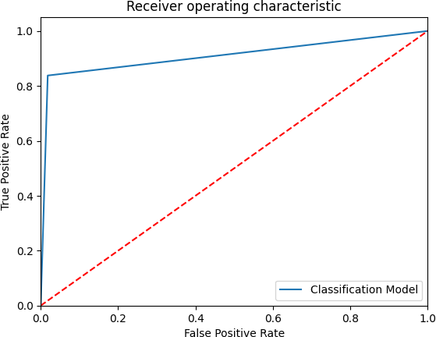

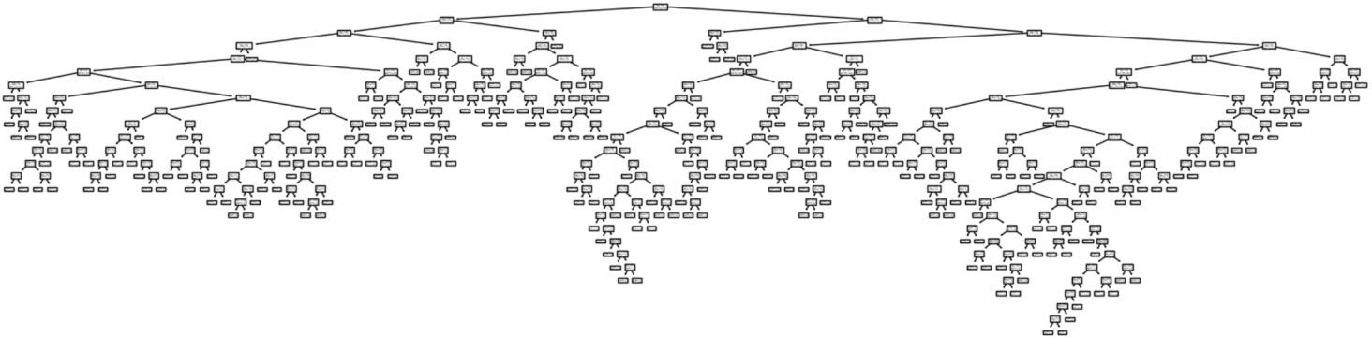

Logistic Regression:
Logistic Regression is a simple yet powerful linear model for binary classification problems.

Mechanism:
Logistic Regression models the relationship between features and the target variable by estimating probabilities using a sigmoid function. The predicted probability is thresholded (e.g., 0.5) to assign class labels.

Strengths:
Fast to train and evaluate.
Works well when there is a linear relationship between features and the target. Provides interpretable coefficients to assess feature contributions.

Limitations:
Struggles with non-linear relationships unless extended with techniques like polynomial features. Sensitive to multicollinearity and imbalanced data.

Relevance to Fraud Detection:
Logistic Regression serves as a baseline model and offers insights into the linear separability of fraudulent and legitimate transactions.

Results:
Confusion matrix :
[[1599 880]
[ 292 2157]]
Outcome values :
1599 880 292 2157
Classification report :
precision recall f1-score support

1 0.85 | 0.65 | 0.73 | 2479
0 0.71 | 0.88 | 0.79 | 2449
accuracy 0.76 4928
macro avg 0.78 0.76 0.76 4928

weighted avg 0.78 0.76 0.76 4928
Accuracy : 76.2 % Precision : 84.6 % Recall : 64.5 % F1 Score : 0.732
Specificity : 88.1 % Balanced Accuracy : 76.3 % MCC : 0.541
roc_auc_score: 0.763
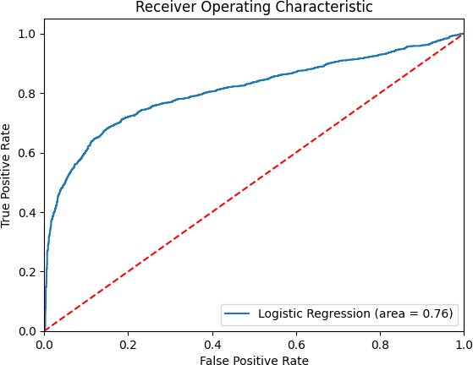

K-Nearest Neighbors (KNN):
KNN is an instance-based learning algorithm that classifies data points based on their similarity to nearby points in the feature space.

Mechanism:
For a given data point, KNN computes the distance (e.g., Euclidean) to all other points in the dataset and assigns the label based on the majority class of the kk-nearest neighbors.

Strengths:
Simple and easy to implement.
Effective for smaller datasets with clear clustering.
Non-parametric, meaning no assumptions are made about the data distribution.

Limitations:
Computationally intensive for large datasets due to distance calculations. Performance is affected by irrelevant features and scaling issues.

Relevance to Fraud Detection:
KNN is useful in capturing local patterns in the data, which can help in identifying clusters of fraudulent transactions.

Results:
Model Name: KNeighborsClassifier(n_neighbors=9) Confusion matrix :
[[2217 262]
[ 116 2333]]
Outcome values :
2217 262 116 2333
Classification report :
precision recall f1-score support

1 | 0.95 | 0.89 | 0.92 | 2479
0 | 0.90 | 0.95 | 0.93 | 2449
accuracy |  |  | 0.92 | 4928
macro avg |  | 0.92 | 0.92 | 0.92 | 4928
weighted avg |  | 0.92 | 0.92 | 0.92 | 4928
Accuracy : 92.3 % Precision : 95.0 % Recall : 89.4 % F1 Score : 0.921
Specificity or True Negative Rate : 95.3 % Balanced Accuracy : 92.4 %
MCC : 0.848
roc_auc_score: 0.923

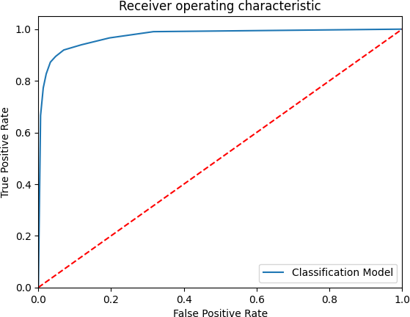

Model Name KNN K Value True_Positive \
0 KNeighborsClassifier(n_neighbors=1) | 1 | 2257
1 KNeighborsClassifier(n_neighbors=2) | 2 | 2131
2 KNeighborsClassifier(n_neighbors=3) | 3 | 2258
3 KNeighborsClassifier(n_neighbors=4) | 4 | 2194
4 KNeighborsClassifier(n_neighbors=5) | 5 | 2247
5 KNeighborsClassifier(n_neighbors=6) | 6 | 2187
6 KNeighborsClassifier(n_neighbors=7) | 7 | 2226
7 KNeighborsClassifier(n_neighbors=8) | 8 | 2188
8 KNeighborsClassifier(n_neighbors=9) | 9 | 2217
False_Negative False_Positive True_Negative Accuracy Precision Recall \
0 | 222 | 168 | 2281 | 0.921 | 0.931 | 0.910
1 | 348 | 64 | 2385 | 0.916 | 0.971 | 0.860
2 | 221 | 143 | 2306 | 0.926 | 0.940 | 0.911
3 | 285 | 93 | 2356 | 0.923 | 0.959 | 0.885
4 | 232 | 130 | 2319 | 0.927 | 0.945 | 0.906
5 | 292 | 90 | 2359 | 0.922 | 0.960 | 0.882
6 | 253 | 110 | 2339 | 0.926 | 0.953 | 0.898
7 | 291 | 93 | 2356 | 0.922 | 0.959 | 0.883
8 | 262 | 116 | 2333 | 0.923 | 0.950 | 0.894
F1 Score Specificity MCC ROC_AUC_Score \
0 0.920 0.931 0.842 <function roc_auc_score at 0x335d98f40>
1 0.912 0.974 0.838 <function roc_auc_score at 0x335d98f40>
2 0.925 0.942 0.853 <function roc_auc_score at 0x335d98f40>
3 0.921 0.962 0.849 <function roc_auc_score at 0x335d98f40>
4 0.925 0.947 0.854 <function roc_auc_score at 0x335d98f40>
5 0.920 0.963 0.848 <function roc_auc_score at 0x335d98f40>
6 0.925 0.955 0.854 <function roc_auc_score at 0x335d98f40>
7 0.919 0.962 0.847 <function roc_auc_score at 0x335d98f40>

8 0.921 0.953 0.848 <function roc_auc_score at 0x335d98f40> Balanced Accuracy
0 | 0.921
1 | 0.917
2 | 0.926
3 | 0.924
4 | 0.926
5 | 0.922
6 | 0.926
7 | 0.922
8 | 0.924

Naive Bayes:
Naive Bayes is a probabilistic classifier that applies Bayes’ theorem with the “naive” assumption of feature independence.

Mechanism:
The algorithm computes the posterior probability of each class given the features and assigns the class with the highest probability.

Strengths:
Computationally efficient and works well with high-dimensional data. Performs surprisingly well with categorical data and text classification tasks.

Limitations:
The assumption of feature independence is rarely valid, affecting performance. Struggles with continuous data unless discretized.

Relevance to Fraud Detection:
Naive Bayes provides a fast and simple baseline model, particularly when feature independence approximates the data distribution.

Results:
Confusion matrix :
[[1207 1272]
[ 427 2022]]
Outcome values :
1207 1272 427 2022
Classification report :
precision recall f1-score support

1 0.74 | 0.49 | 0.59 | 2479
0 0.61 | 0.83 | 0.70 | 2449
accuracy |  | 0.66 | 4928
macro avg | 0.68 | 0.66 0.65 4928
weighted avg | 0.68 | 0.66 0.65 4928

Accuracy : 65.5 % Precision : 73.9 % Recall : 48.7 % F1 Score : 0.587
Specificity : 82.6 % Balanced Accuracy : 65.6 % MCC : 0.332
roc_auc_score: 0.656
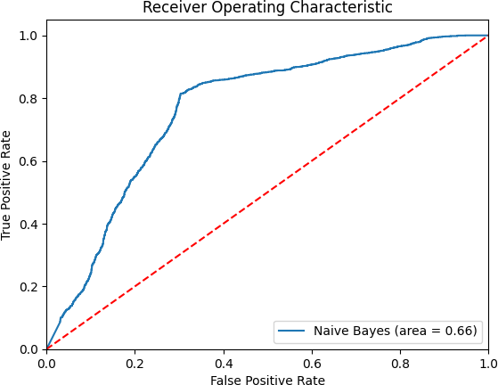

Linear Probability Model (LPM):
LPM is a linear regression model adapted for binary outcomes, where the predicted output represents the probability of belonging to a class.

Mechanism:
The model uses a linear combination of features to predict probabilities, which are thresholded to classify data points.

Strengths:
Simple to implement and interpret.
Serves as a baseline model for binary classification tasks.

Limitations:
Poor performance in classification tasks due to its inability to model non-linear decision boundaries. Produces probabilities outside the [0,1] range, which can be unrealistic.

Relevance to Fraud Detection:
LPM is included as a comparison to evaluate the effectiveness of more advanced models.

Results:
Model Name: Linear Probability Model Confusion matrix :
[[1479 1000]
[ 284 2165]]
Outcome values :
1479 1000 284 2165
Classification report :
precision recall f1-score support

1 0.84 | 0.60 | 0.70 | 2479
0 0.68 | 0.88 | 0.77 | 2449
accuracy |  | 0.74 | 4928
macro avg | 0.76 | 0.74 0.73 4928
weighted avg | 0.76 | 0.74 0.73 4928
Accuracy : 73.9 % Precision : 83.9 % Recall : 59.7 % F1 Score : 0.697
Specificity or True Negative Rate : 88.4 % Balanced Accuracy : 74.0 %
MCC : 0.501
roc_auc_score: 0.78
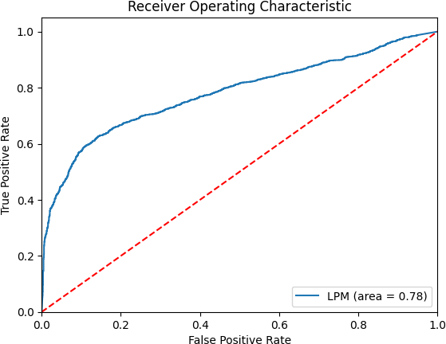

Metrics Used to Assess Models
To evaluate the performance of the models in this project, the following metrics were utilized. These metrics are derived from the confusion matrix, which provides a summary of the prediction results.

Confusion Matrix
The confusion matrix is a table that describes the performance of a classification model by comparing actual and predicted values. It consists of four components:
True Positives (TP): Correctly predicted fraudulent cases. True Negatives (TN): Correctly predicted legitimate cases.
False Positives (FP): Legitimate cases incorrectly classified as fraudulent. False Negatives (FN): Fraudulent cases incorrectly classified as legitimate.

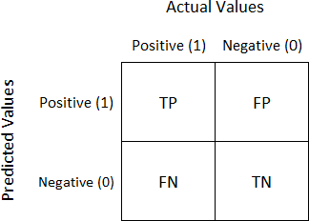

From this matrix, various metrics can be calculated:

Accuracy
Definition: Accuracy measures the proportion of all correct predictions (TP + TN) over the total predictions.
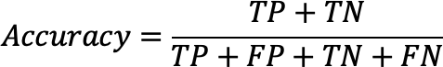

Interpretation: Accuracy provides an overall performance measure. However, it can be misleading for imbalanced datasets, such as fraud detection, where the number of legitimate cases far outweighs fraudulent ones.

Precision
Definition: Precision focuses on the fraction of true fraud cases (TP) out of all cases predicted as fraud (TP + FP).
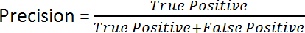

Interpretation: Precision is crucial in scenarios where false positives (legitimate cases flagged as fraud) are costly or disruptive.

Recall (Sensitivity)
Definition: Recall measures the fraction of actual fraud cases (TP) that were correctly predicted.
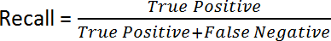

Interpretation: Recall is essential in minimizing false negatives, ensuring that actual fraud cases are not missed.

F1-Score
Definition: The F1-score combines Precision and Recall into a single metric to provide a balanced view of the model's performance.
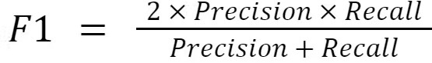
Interpretation: The F1-Score is especially useful for imbalanced datasets, balancing the trade-off between Precision and Recall.

ROC-AUC (Receiver Operating Characteristic - Area Under the Curve)
Definition: The ROC-AUC measures the model's ability to distinguish between classes across various classification thresholds.

Key Concepts:
The ROC Curve plots the True Positive Rate (Recall) against the False Positive Rate.
The AUC (Area Under the Curve) value indicates the overall performance. A value closer to 1 signifies better discriminatory power.
Interpretation: ROC-AUC is a threshold-independent metric, making it valuable for assessing models in imbalanced datasets like fraud detection.

Results:
The evaluation of the models used in this project was based on key performance metrics such as Accuracy, Precision, Recall, F1-Score, and ROC-AUC. The table below summarizes the performance of various models:
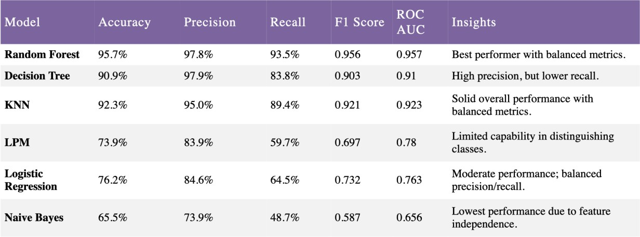

Visualization
To further illustrate the comparative performance of the models, the bar chart below provides a visual representation of metric such as Accuracy across all algorithms.
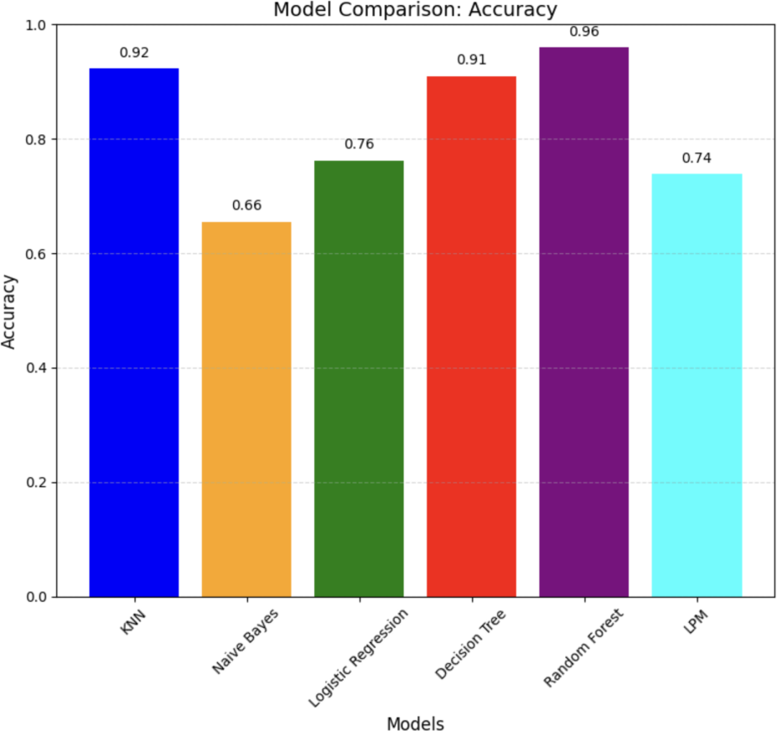
This visualization highlights the performance gap between the Random Forest model and other

algorithms, demonstrating its superior metrics. It also helps identify the relative strengths and weaknesses of each model in terms of different metrics.

Analysis
- Random Forest:
The Random Forest model demonstrated the best overall performance with the highest Accuracy (95.7%), Precision (97.8%), and ROC-AUC (0.957). This indicates that it effectively distinguished between fraudulent and legitimate transactions while maintaining a balance between false positives and false negatives.

Decision Tree:
While the Decision Tree model achieved a high Precision (97.9%), its Recall (83.8%) was comparatively lower, indicating it might miss some fraudulent cases. Nevertheless, its overall performance was strong, with a ROC-AUC of 0.91.

K-Nearest Neighbors (KNN):
The KNN model provided solid performance, with balanced metrics such as Precision (95.0%) and Recall (89.4%), resulting in a high F1-Score (0.921). Its ROC-AUC (0.923) suggests strong discriminative ability.

Linear Probability Model (LPM):
The LPM showed limited capability, with a lower Recall (59.7%), resulting in fewer fraud cases being detected. Despite this, it achieved a reasonable Precision (83.9%), indicating that when fraud was predicted, it was often correct.

Logistic Regression:
Logistic Regression achieved a balanced trade-off between Precision (84.6%) and Recall (64.5%). With an F1-Score of 0.732 and a ROC-AUC of 0.763, it performed moderately well.

Naive Bayes:
The Naive Bayes model had the lowest performance across all metrics, with an Accuracy of 65.5% and an F1-Score of 0.587. Its limitations stem from the assumption of feature independence, which likely affected its ability to capture relationships between features.

Key Insights
  - The Random Forest model stands out as the most robust and reliable choice for this fraud detection project, given its superior performance across all metrics.
  - Decision Tree and KNN models also provided strong performance and could serve as potential alternatives depending on the trade-off between precision and recall requirements.
  - Simpler models such as Logistic Regression, LPM, and Naive Bayes were outperformed, highlighting the importance of model complexity and feature interaction in this dataset.
By evaluating these metrics, the project's objectives of identifying fraudulent transactions with minimal errors were addressed effectively.

Conclusion:
The study highlights the Random Forest model's superior performance in detecting fraudulent transactions, demonstrating the critical importance of selecting models based on precision and recall metrics. By addressing challenges such as imbalanced data and complex feature spaces through tailored preprocessing and training strategies, this project significantly contributes to enhancing digital banking security. The findings validate the effectiveness of machine learning models in reducing fraud and financial losses, underscoring the necessity of ongoing research to integrate dynamic data sources and continuously update models to counter evolving fraud tactics. Ultimately, this work underscores the vital role of advanced data mining techniques in strengthening financial security and sustaining customer trust in an increasingly digitalized world.

References
- Shmueli, G., Bruce, P. C., Yahav, I., Patel, N. R., & Lichtendahl, K. C., Jr. (2018). Data mining for business analytics: Concepts, techniques, and applications in R (3rd ed.). Wiley.
- Lemaitre, G., Nogueira, F., & Aridas, C. K. (2017) - Imbalanced-learn: A Python Toolbox to Tackle the Curse of Imbalanced Datasets in Machine Learning.
- Zhang, Z., & Lu, J. (2018). Evaluation metrics for imbalanced learning. International Journal of Machine Learning and Cybernetics, 9(1), 1-25.

